AGENCY CREATION
STEP 1- We received email for creation from sales.
Go to Quelnet ->select Creation agency AMBSF
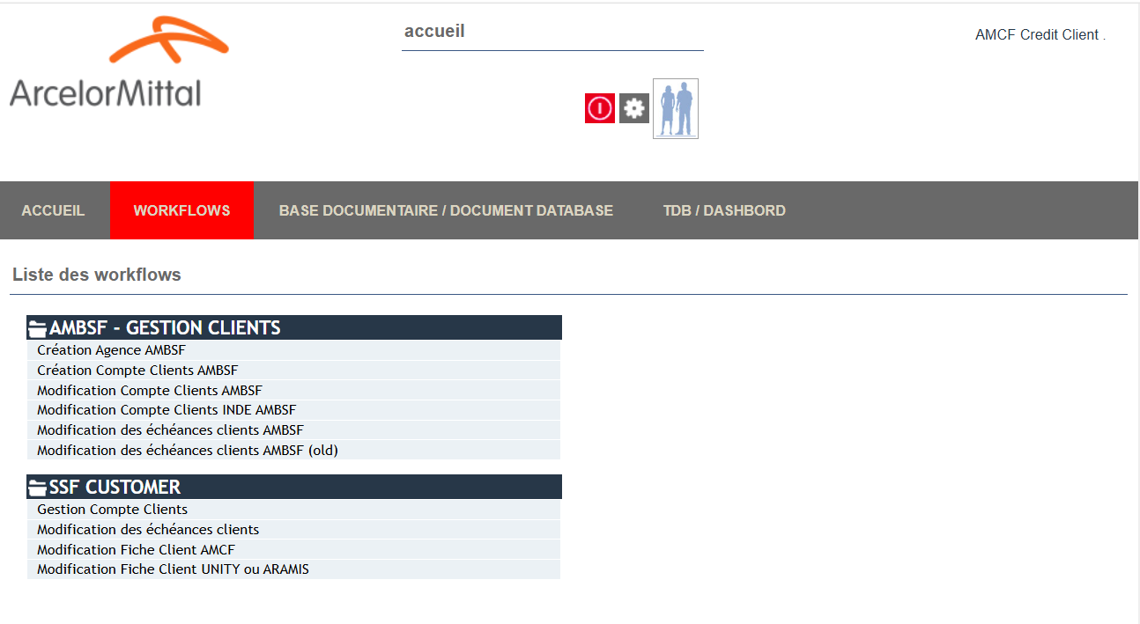

Open above selection in red. Go to new listing indicated in red in below sheet
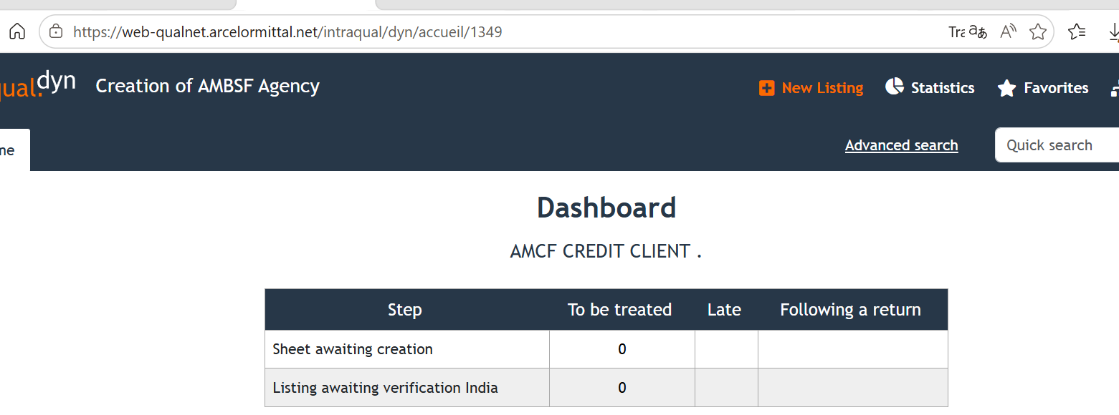
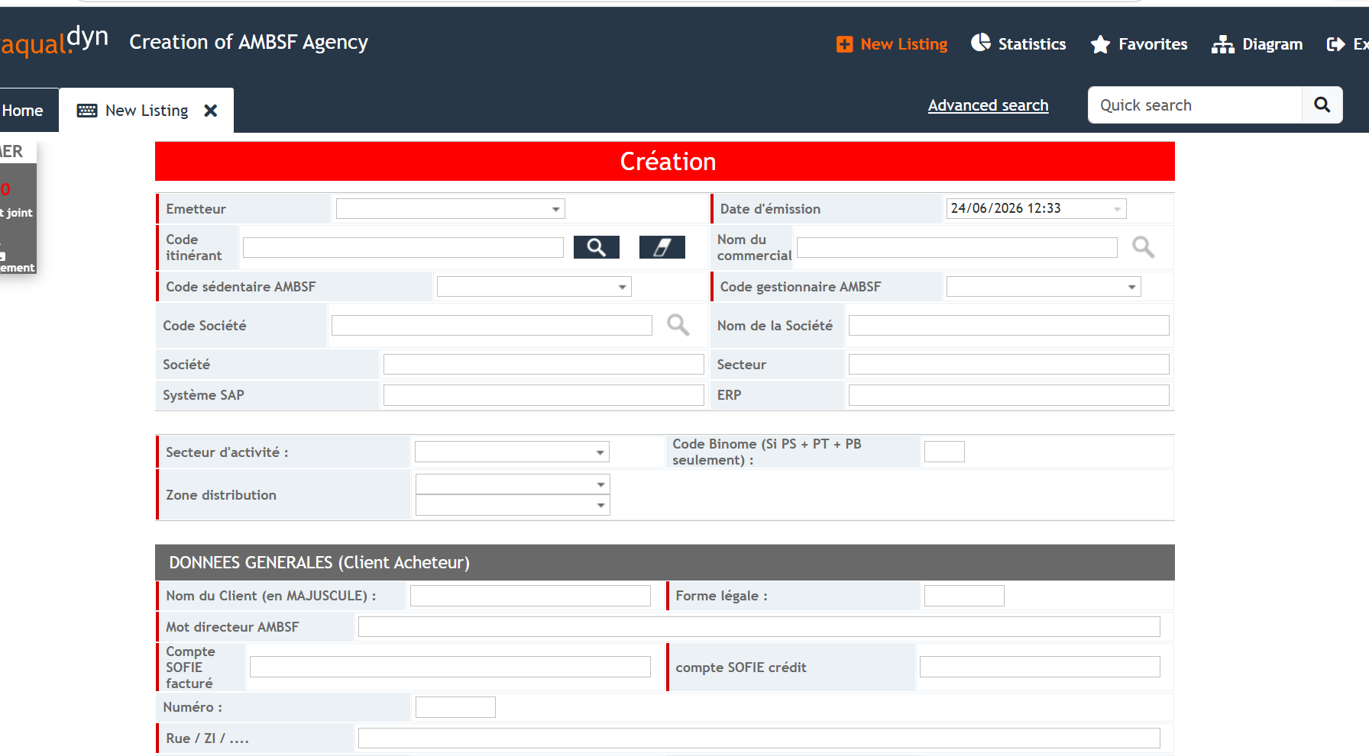
Feed this sheet according to details given in email
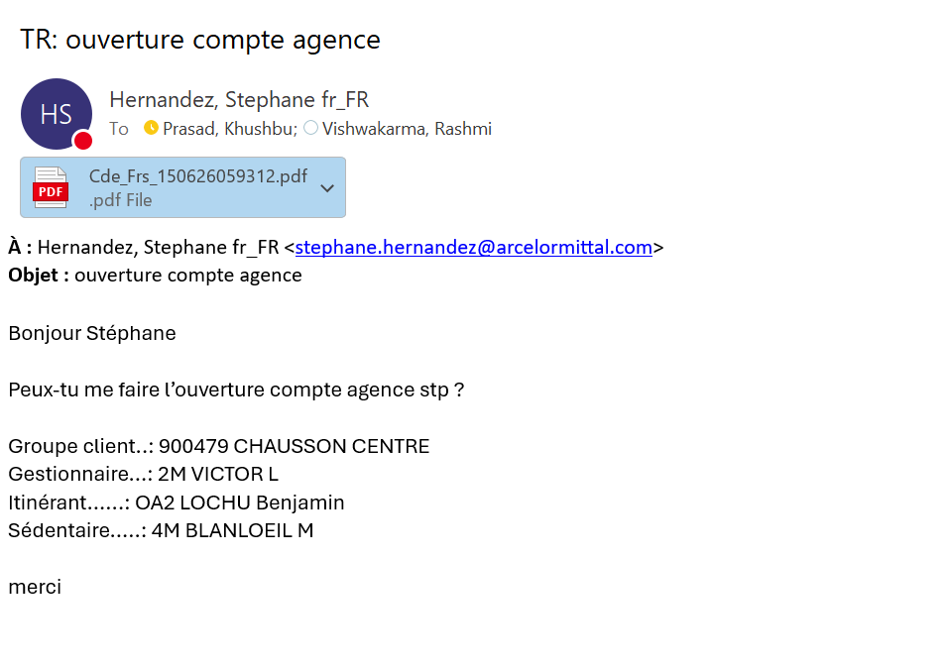
For Emetteur- select
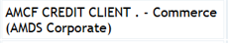
Code itinerant, Code gestionnier, Code sedentaire- given in mail
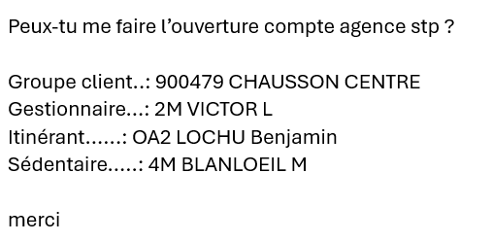
Secteur activity- it will be in email, if not given then select 00 as shown in below sheet.
Zone distribution- always FR and France.
Nom du Client- name of customer on invoice + Agency , also legel form if is there.
Mot directure- Name of customer + first 2 digit of postal code + agency name
Compte sofie factures and compte sofie credit- go to sofie search by siren no. then take and oldest account of the customer, open with 03,01, 07 you get this screen below.
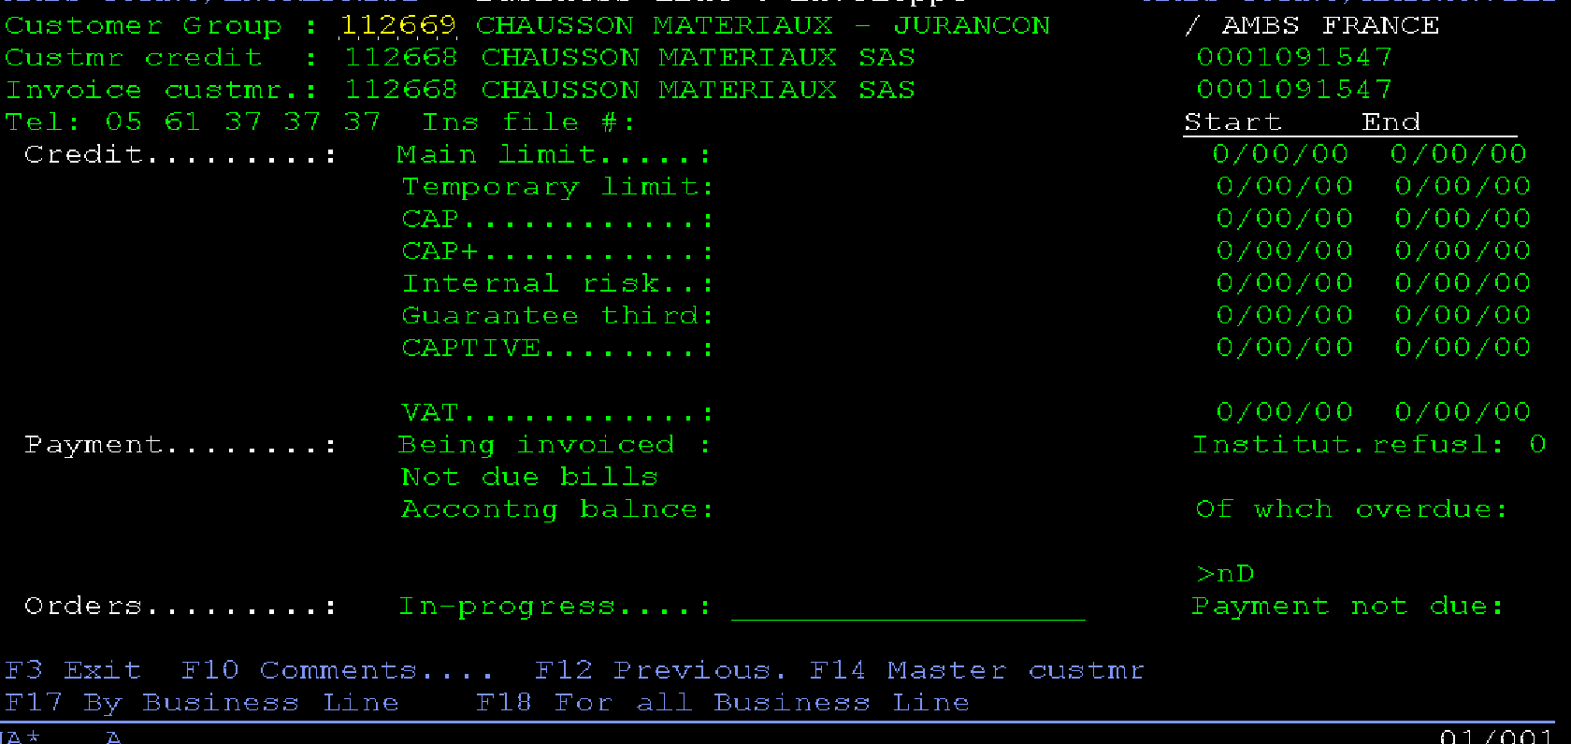
For address you have to select address of delivery-
